KEELE PARISH COUNCIL
SAFEGUARDING POLICY

Policy Statement
In the interests of child protection and the welfare and protection of vulnerable adults, Keele Parish Council is committed to ensuring that children and vulnerable adults are protected and kept safe from harm whilst they are engaged in any activity associated with the Parish Council. Safeguarding children and vulnerable adults is everyone’s responsibility.

Policy Objective:
• To ensure that where possible all facilities and activities offered by the Parish Council are designed and maintained to reduce the risk to children and vulnerable adults.
• To promote the general welfare, health and development of children by being aware of child protection issues and to be able to respond where appropriate as a local government organisation.
• To develop procedures in recording and responding to accidents and complaints and to alleged or suspected incidents of abuse and neglect.
• As the Parish Council does not directly provide care or supervision services to children and vulnerable adults, it expects all children and vulnerable adults using its facilities to do so with the consent and the necessary supervision of a parent, carer or other responsible adult.

Aims
The aim of this policy document is to guide members of Keele Parish Council should any child protection issue or any issues with vulnerable adults arise during their work.

Responsibilities & Procedures
The Council will appoint a Safeguarding Officer from within the Council and their responsibilities will include:
• Ensuring that before any Parish Council organised event with children or vulnerable persons, the Designated Safeguarding Lead briefs participants appropriately.
• Ensuring that members are aware of the risk they may face in certain circumstances whilst carrying out their duties.
• Ensuring that whilst Council members are unlikely to be involved with children during the performance of their duties they are mindful of the risk they face.
• Ensuring that before any volunteers or paid members of staff are recruited to work with children and vulnerable persons they are interviewed and two references taken up.
• Decisions on whether any person should be DBS checked will be made by the Council or the Chairman after consultation with the Clerk following a risk assessment.
• All Councillors are to be provided with a copy of the Safeguarding Policy and are required to acknowledge and sign to confirm they will abide by it. All new Councillors will also be required to sign.
• Councillors will adhere to the ‘List of Recommended Behaviour’ namely:
- A minimum of two adults present when supervising children.
- Not to play physical contact games.
- Adults to wear appropriate clothing at all times.
- Ensure that accidents are recorded in an accident book.
- Never do anything of a personal nature for a young person.
- Keep records of any incidents or allegations a person may make to any committee member or volunteer.
- Refer cases of suspected abuse or allegations to the Designated Safeguarding Lead who will be responsible for ensuring the matter is handled in accordance with the Local Safeguarding Children Board procedures.
• Facilities offered by the Parish Council have been inspected on a regular basis and at least annually by a representative of RoSPA or a similar organisation.
• Sharing information about child protection and good practice with partner organisations, councillors, employees, volunteers, parents and carers.
• In the event of a contractor, working directly for the Parish Council, being deemed to be working in any area where children or vulnerable adults may be at risk, then that contractor will be asked to provide their Safeguarding Policy.

Any organisation which may make contact with children or vulnerable adults shall be required to show proof of its own appropriate Safeguarding Policy before being allowed to participate in the use of any council owned facilities.

Declaration
Keele Parish Council is fully committed to safeguarding the well-being of children and vulnerable adults by protecting them from physical, sexual, emotional harm, neglect including cyber bullying, sexting and peer on peer abuse.

All members of Keele Parish Council should read the Safeguarding Policy. Having read the Policy they should be proactive in providing a safe environment for children and vulnerable people who are involved in Parish Council activities.

This Policy will be reviewed annually at or before the Annual Council meeting in May each year.

Reviewed: April 13th 2026

Signed:
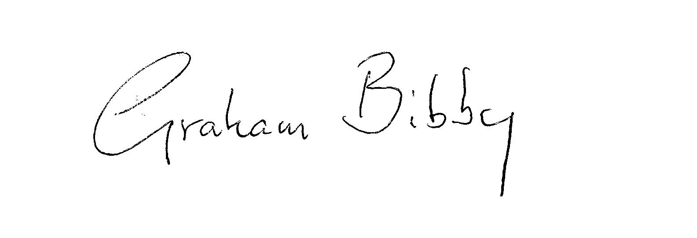Chair of Keele Parish Council
Date: 13th April 2026

